PROVIDER DISCHARGE PROCESS
HCS PROVIDER DISCHARGE

HCS – HEALTHCARE SYSTEMS
Phone: 334-279-9711
HCSSupport@hcsinc.net


STEPS:
- Complete paper discharge per facility process, excluding medication reconciliation.
- Locate patient in HCS
- Verify preferred pharmacy if desire to ePrescribe
- Select Discharge Tab
- Mark each medication as Rx, Continue or Stop
- Select eSign or eSign and Send as appropriate

UPDATING PREFERRED PHARMACY


- In the “Preferred Pharmacy” box, begin entering Name, City, State or ZIP to start search.
  - Can search “Walgreens in Springfield” or “CVS in 36117”. Make selection from results.

*Any pharmacy that produced results from the query will show as an option.


COLUMNS/COLORS/CODES
- Status Column – will show origination of medication order
  - H (Red)– Patient was taking this medication at home, but it was not continued in the hospital
  - H-MQ (Red) – Medication came from Med query but was not reconciled at admission. (*This is a workflow problem)
  - I (Green) – Inpatient
  - B (Blue) – Home medication continued the saw way in the hospital
  - H, I, B (Purple) – Linked medications, they are alike but something is different. Be aware when reconciling.
- RX Column - will show if prescriptions were indicated
- E-RX Column -
  - Icons and codes formulary status, copay information whether or not a medication is OTC, and whether the prescription has been sent. The column displays a question mark (?) if the formulary status is unknown
- After the prescription is sent, the insurance statuses disappear and are replaced by e-prescription statuses

TO ePRESCRIBE
- Provider must have ePrescribe access
- Patient must have preferred pharmacy listed
- All medications must be addressed with RX, Continue or Stop

AFTER SELECTIONS ARE MADE
- An Rx Send Summary window is displayed, allowing final check and confirmation of prescriptions to be eprescribed

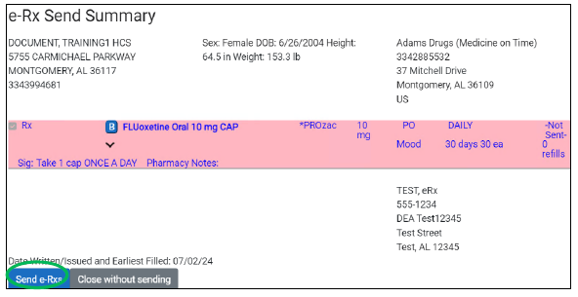

- Send e-Rxs button to complete the process


